Southern Tier Chapter of
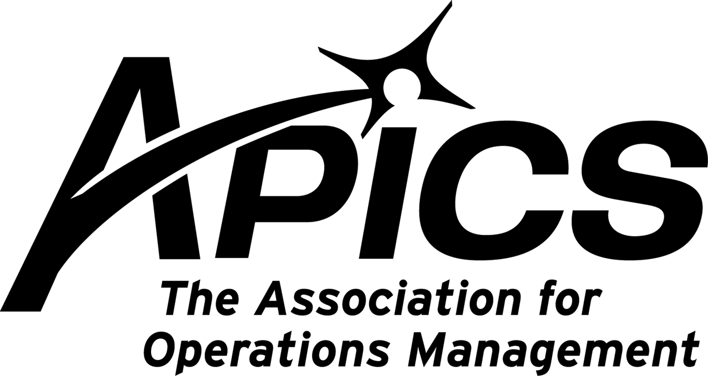

“Advancing productivity and innovation and competitive success.”

APICS Northeast District Meeting
Corning, NY
November 6 & 7th, 2009

Overnight accommodations at the:
Radisson Hotel Corning
125 Denison Parkway East
Corning, NY 14830
www.radison.com/corningny
800-395-7046 or 607-962-5000

The APICS rate is $89 a night plus tax and is valid through October 25th. You must mention APICS (spell it, to be sure) when requesting the rate. This rate will be available for a limited number of rooms for Saturday night. Enjoy a great family experience featuring the Corning Glass museum and the Rockwell Gallery museum. Again, you must mention APICS when requesting the rate.
Don’t wait! It’s vacation season.
There are a limited number of rooms, so make your reservations NOW!

To register for the District meeting registration, visit our web site www.apicsnortheast.org.

“Focus on APICS Education and Career Transitions”

- APICS Association update from Anthony Zampello, District Director.

- Chapter Best Practices: We want to hear from YOU!
If you would like to share a best practice, please respond back to this Newsletter.

Meet old and new friends, learn new skills, and expand your network in the serene beauty of Corning, New York at the November APICS Northeast District Meeting.

APICS News from Don Sheldon, Vice President of Education

- CSCP – The economic situation has made it hard for some to support the cost of education right now but we are still seeking interest. We would especially like to hear from people who have interest in a CSCP course offering. To date we have been unsuccessful at getting a minimum class size. I have one person from EIT interested but no one else to date. Please let me know if you are interested. This includes previous interested parties from the spring requests as I know many things have changed since our last correspondence in the spring.

- CPIM – There are seats left in one CPIM course offered this fall.
- Update only - SMR, the last in the 5-class CPIM series is being offered at BCC on Tuesday evenings. Its probably too late to join this class. It has been going for a few weeks.
- Basics, the first class in the 5-class CPIM series is starting on 2 November, Monday afternoons 2:30-5:30 pm at BCC,. Normal pricing applies which is $450 plus book price of $85 for members. Non-member class registration is higher to cover the membership fee. Contact dsheldon@sheldoninc.com to register or for more information.
- Master Planning of Resources, class 2 in the CPIM series will also be held starting in January at BCC. More to follow as dates firm.

- I will not be leaving the Board of Directors – As some of you may know I have accepted an appointment as the National Committee Chair for APICS OMBOK (Operations Management Body of Knowledge). I had initially been informed that I would not be able to serve on the local and national levels simultaneously but have learned since that it is not a problem. I therefore will not be resigning at the end of the year as planned. Anybody interested in the position is invited to come forward, however, because I am always looking for an understudy!

- Report from the International Conference in Toronto – I was fortunate enough to be a speaker at the APICS International Conference in Toronto this month. I ran into Pat Rogan from MeadWestvaco there but no one else from the Southern Tier Chapter. You all missed a great conference. The speakers were high quality (I am not referring to me. ☺) and the networking was great. There were many more overseas attendees this year than I remember from past conferences. I am told that APICS certifications outside North America are way up which confirms great value in the certification achievement. I hope all of you will be able to attend the conference in 2010 in Nashville.

- District Meeting – All welcome! – The North East District APICS meeting will be held in Corning this time. It is rarely held this close to Binghamton and it is a great opportunity to see how your organization works and to meet others in our professional society. There is a hospitality room on Friday evening, 6 November and a district meeting that all members are invited to attend on Saturday morning, 7 November. The sessions will be at the Radisson in Corning, NY. For more information or to make a reservation log on to http://www.apicsnortheast.org/ . Hope to see you there!

Educational Opportunities!!!

Enterprise Resource Planning – Getting the Payback From Your ERP System.
National Teleconference ● Wednesday, November 11, 2009 ● 1:00 PM – 2:30 PM EST
Presented by Donald H. Sheldon of DH Sheldon & Associates

Use attached brochure to register today!!

Your 2009-2010 Board of Directors

President Dave Gardner dgardner@akraturn.com
Education Director Don Sheldon dsheldon@stny.rr.com
Secretary Deb Unkel deb.unkel@raymondcorp.com
VP Membership Lee Schechter lschechter@stny.rr.com
VP Programs Michael LoSapio mlosapio@visualtechgroup.com
Executive VP /Director of Finance Steve Whited sjw6@meadwestvaco.com
Web site Michael LoSapio mlosapio@visualtechgroup.com
Publicity / Marketing Kelly Noreika Kelly.noreika@lcmo.com

Southern Tier APICS
PO Box 1107
Binghamton NY 13902-1107

